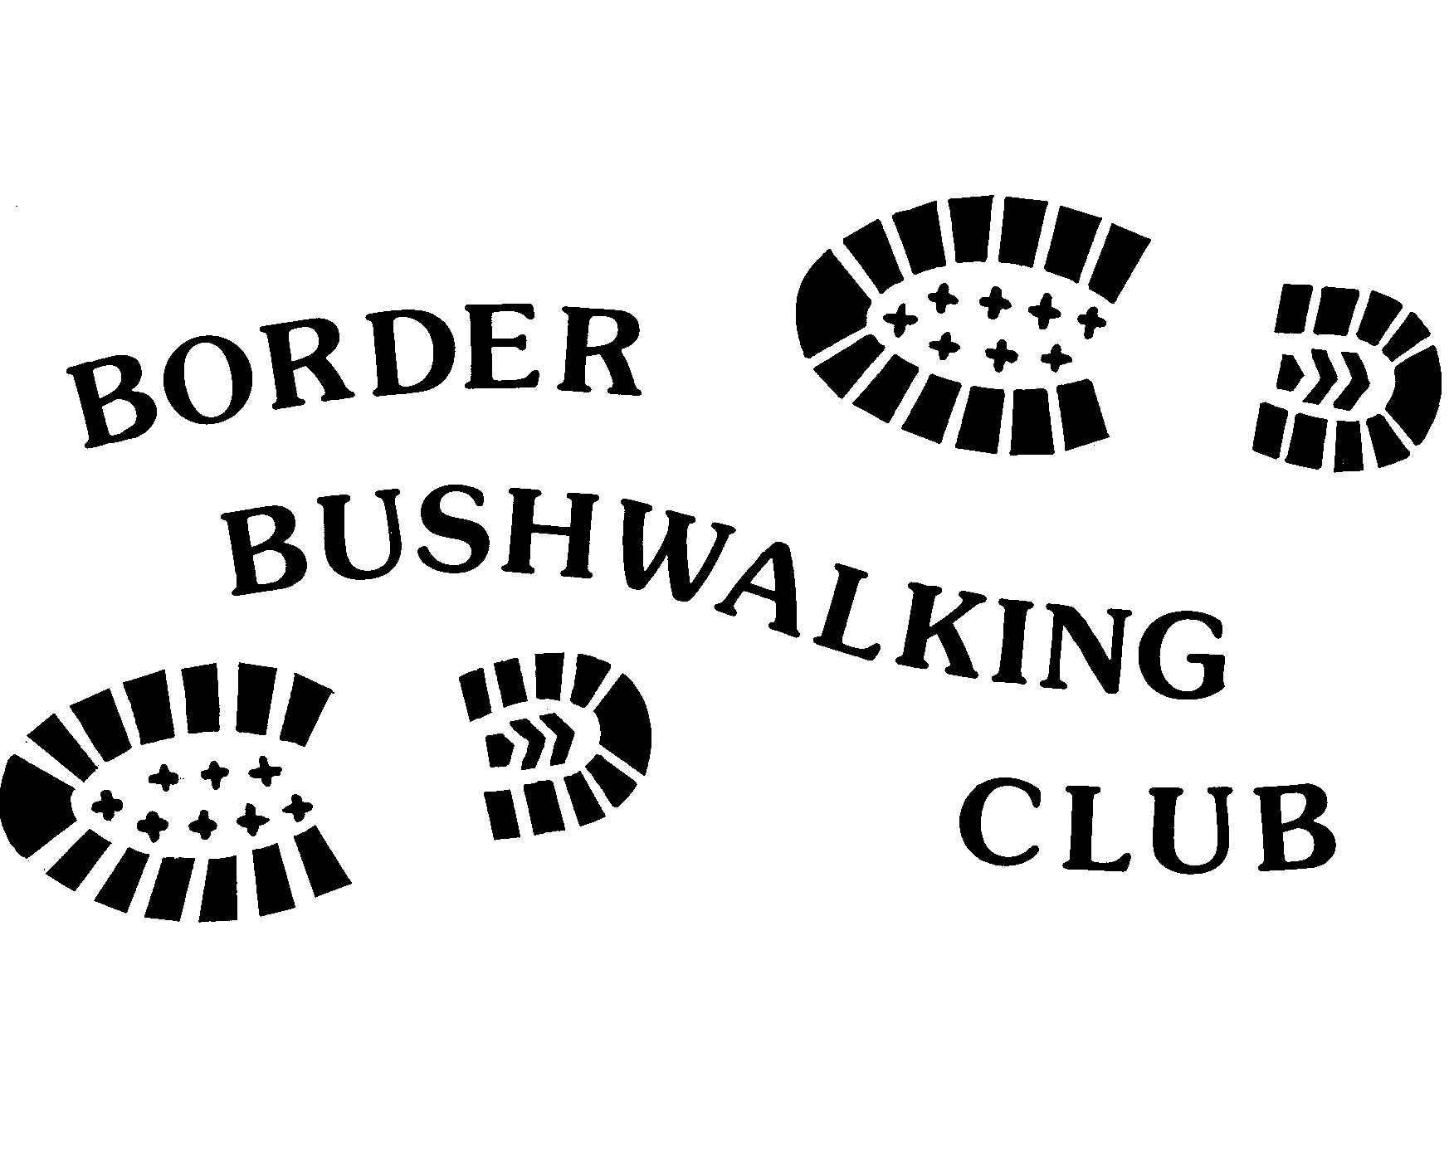
BORDER BUSHWALKING CLUB
Association Number A 5665B

PARTICIPANT’S EMERGENCY CONTACT & MEDICAL INFORMATION

This information is for emergency use only and is to be carried in your pack at all times in a sealed plastic container / envelope. It is your responsibility to update this information if there is a change in details.

Participant Details:

Name: _________________________________________________________________________________

Home Address: __________________________________________________________________________

_____________________________________________ Post Code ___________________

Telephone: Home: _______________________________ Mobile: __________________________________

Date of Birth: _________________________________ Car Registration No: ________________________

Medical Information:

Medical Condition(s) : _____________________________________________________________________

________________________________________________________________________________________

Current Medication(s) : _____________________________________________________________________

________________________________________________________________________________________

Allergies: ________________________________________________________________________________

Do you have current immunisation against: Tetanus Y/N HepA Y/N HepB Y/N

Medicare Number: _____________________________Private Health Fund: ___________________________

Ambulance subscriber Y/N Membership No: (if known) __________________________________________

Emergency Contact::

Name: _____________________________________________________Relationship____________________

Home Address: ____________________________________________________________________________

______________________________________________Post Code _____________________

Telephone: Home ________________________________ Mobile ____________________________________

Privacy Statement:
The information contained in this form is for emergency use only and will be used if you are ill or injured whilst participating in an activity of Border Bushwalking Club. The information will only be accessed by the walk leader or their delegate and given to the relevant medical and/or emergency services personnel.

Signed: _____________________________________________________ Date: ________________________

